**Simplified ALU Design on the next A7 Artix-7 FPGA Board  
  
Relevant outputs/screenshots:**

**Testbench output:**

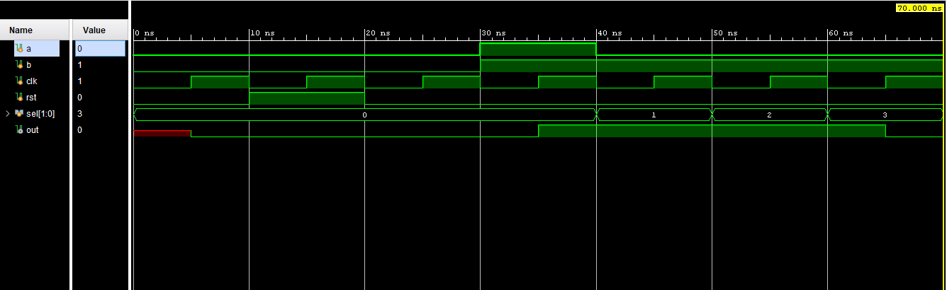

**Elaborated Design:**

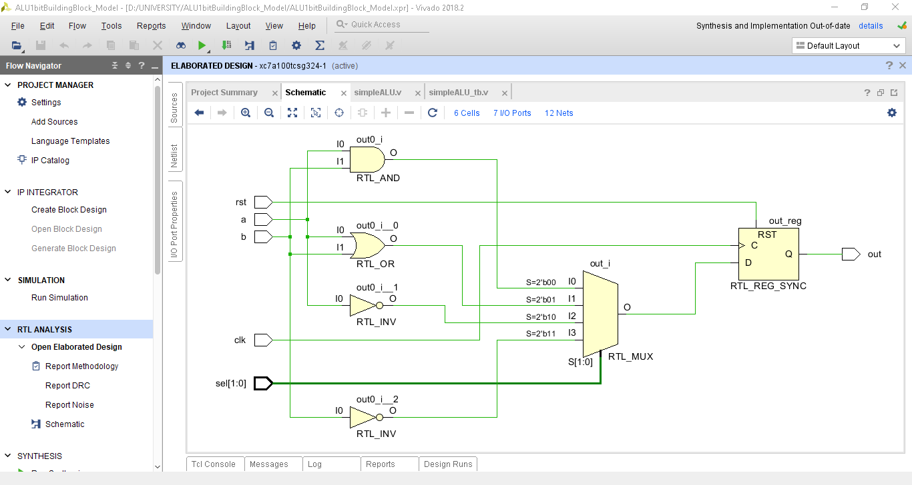

**NEXYS A7 Board Outputs:**







